MINISTRY OF LAND, WATER AND ENVIRONMENT

Project: Enabling Programs for sustainable Management of Land, Water and environmental resources

Activity 1: Undertake workshop training Program on Geographic Information System and Remote Sensing
Participants: Participants were 23 from different relevant sectors and five zoba administrations and was conducted for five days:
Duration: the training was conducted for five days from June 23 to 27, 2025,
Purpose/significance of training:
The purpose of the mission was to conduct a five-day capacity building program for staffs at the Ministry of Land, Water, and Environment, specifically targeting critical knowledge and skill gaps in Geographic Information Systems (GIS) and Remote Sensing (RS). These gaps had been identified by the Ministry as significant obstacles to effective performance. The training was therefore designed to strengthen the staff’s understanding and practical abilities in using GIS and RS technologies. By doing so, the training was aimed to enable staffs to apply these tools more effectively in their daily work, support assessment studies and research, enhance the implementation of various programs and projects, and improve the Ministry’s overall Geospatial information management systems. Specifically, the training aims to:
- Develop an understanding of GIS and remote sensing principles and tools and their applications in sustainable management and governance of land, water, environmental resources and cadastral mapping.
- Enable participants to use GIS and remote sensing software for spatial data capture, processing, analysis, and visualization to inform sustainable resource management strategies.
- Enhance capacities for accurate assessment and monitoring of natural resources, such as soil, water, forests, and land parcels, to support integrated management and conservation efforts.
- Promote the use of geospatial technologies for improved land administration, cadastral services, urban planning, and environmental impact assessments, contributing to sustainable development and risk mitigation.
- Prepare participants to apply geospatial data for resource inventory, watershed management, flood and drought monitoring, land tenure security, and sustainable land and environmental governance.
- Support implementation of global frameworks like Sustainable Development Goals (clean water, land conservation), climate adaptation, and ecosystem-based management through spatial data-driven approaches.
In addition to theoretical sessions, the workshop emphasized hands-on exercises to build practical competencies in managing geospatial databases, processing remote sensing data, and conducting spatial analysis relevant to environmental monitoring and resource management. Participants gained experience in digitizing, geo-referencing, and populating geodatabases, as well as using advanced platforms such as Google Earth Engine and AI tools for big data compilation. The workshop concluded with discussions on applying these skills to support the Ministry’s programs, improve information management systems, and enhance decision-making processes related to sustainable land and water resource management in Eritrea.

This training was conducted with technical assistance (trainers) from Economic Commission for Africa (ECA) during

S_No |  | Courses | Participants
S_No |  | Courses | Female | Male | Total
1 | Theoretical | Remote sensing fundamentals | 3 | 20 | 23
2 | Theoretical | image interpretation | 3 | 20 | 23
3 | Theoretical | satellite missions (Sentinel-1 and Sentinel-2) | 3 | 20 | 23
4 | Practical | managing geospatial databases | 3 | 20 | 23
5 | Practical | processing remote sensing data | 3 | 20 | 23
6 | Practical | conducting spatial analysis | 3 | 20 | 23

The Workshop training program in pictures
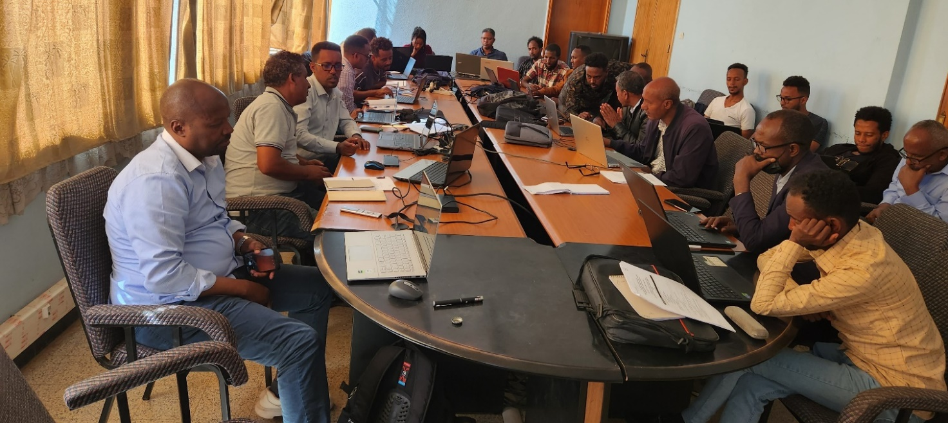
Picture 1
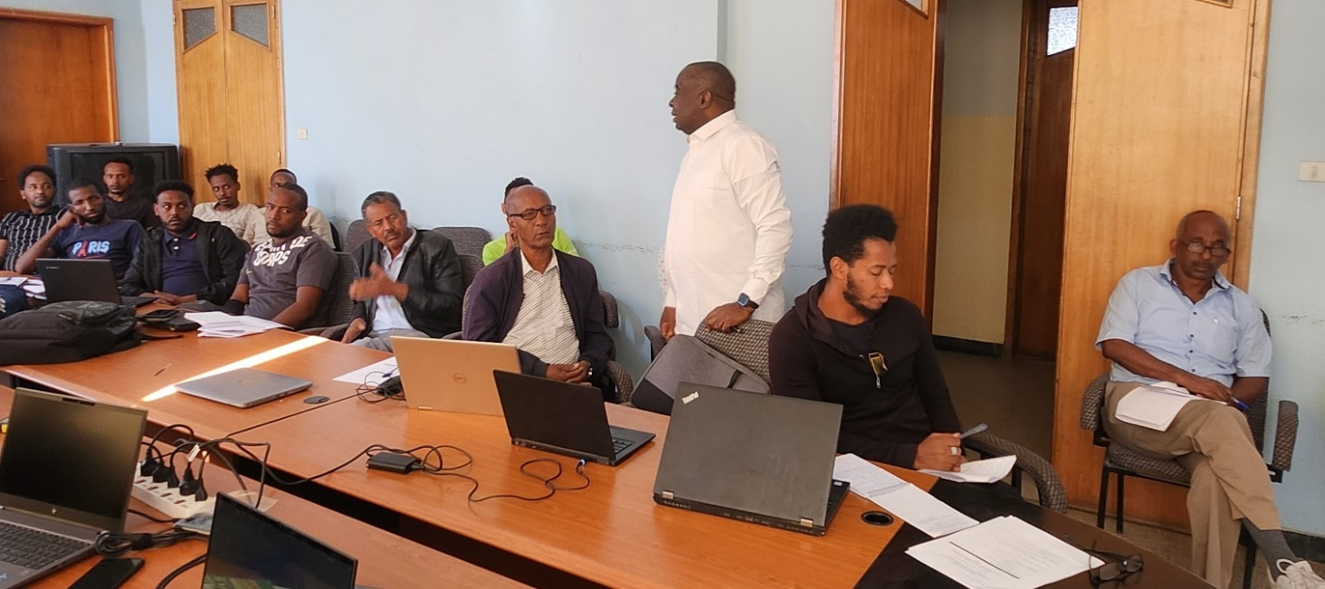
Picture 2
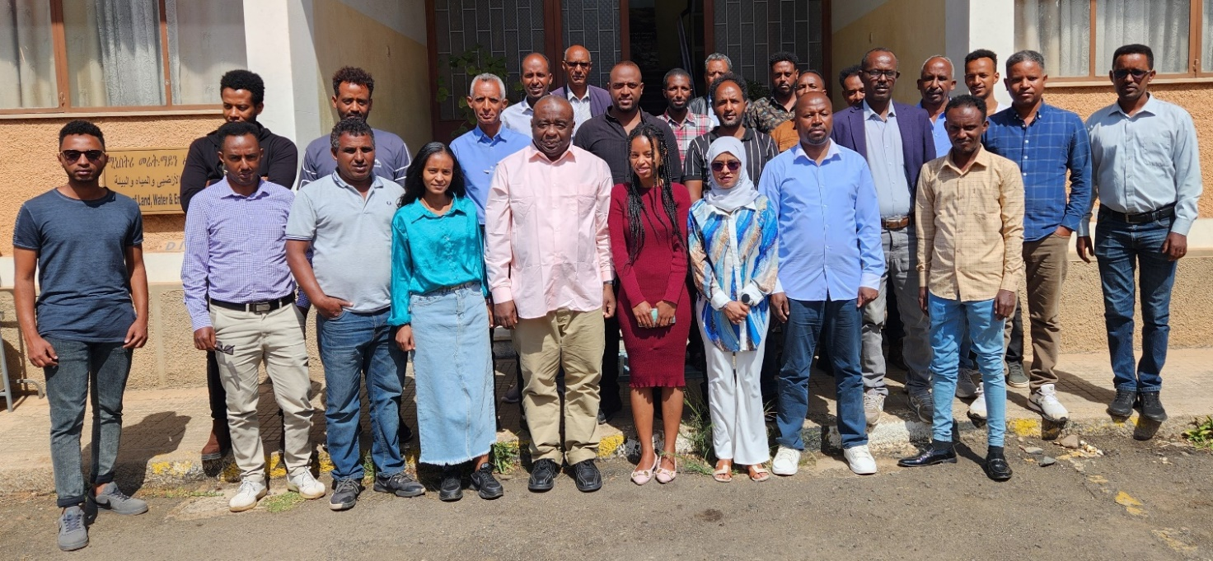
Activity 2: Training Program of Electronic Information Resources Management.
Objective: to enhance knowledge and skill of staff on electronic information resources management
Participants: 22 from departments of the Ministry and zoba branches of the Ministry
Duration: the training was conducted for ten days from June 15/09/2025 – 2/09/2025
S_No | Courses | Participants
S_No | Courses | Fem | Male | Total
1 | Module 1  - Understanding the Context of Electronic Information Management  - The Opportunities and Challenges of Electronic Record  - The Importance of Metadata | 9 | 13 | 22
2 | Module 2  - Planning and Managing an Electronic Info. Management Programme  - -Developing a Business Case for Improved Electronic Information Management | 9 | 13 | 22
3 | Module 3  - Managing the Creation, Use and Disposal of Electronic Information  - Developing Classification Schemes  - Managing Electronic Information  - Appraising and Disposing of Electronic Information | 9 | 13 | 22
4 | Module 4  - Preserving Electronic Records and Basic Digital Preservation Practices  - Current Research and Future Directions | 9 | 13 | 22
5 | Module 5  - Managing Personnel Records in an Electronic Environment.  - Improving Personnel Record-keeping Sys & Verifying Payroll  - Moving Toward Electronic Personnel Record Keeping | 9 | 13 | 22
Activity 3: The Ministry if planning to provide training on sustainable management of land, water and environmental resources
Participants: the participants will be the newly assigned 290 young staff who have no/little konwlege about the nature of mandate of the Ministry and management of land, water, environment and cadastral services.

S_No |  | Courses | Participants
S_No |  | Courses | Female | Male | Total
1 | MLWE | - Correspondence writing skills  - Record management  - Office management  - Computer application | 31 | 9 | 40
2 | Land resources | - Organization Structure and work relations  - Land Proclamation 58/94  - Legal Notice 95/97  - Directives to implement the Land proclamation 58/94 | 60 | 35 | 95
2 | Land resources | - Land use and cartography  - Land use  - Cartography | 60 | 35 | 95
2 | Land resources | - Management of conflicts in relation to land issues | 60 | 35 | 95
2 | Land resources | - Land Database | 60 | 35 | 95
2 | Land resources | - Geographic Information system | 60 | 35 | 95
3 | Water resources | - Briefings on Regulatory Instruments (water Law and Directive on Groundwater Works)  - Introduction to Hydrometeorology  - Water Resources Overview of Eritrea | 41 | 41 | 82
3 | Water resources | - Introduction to Hydro- meteorology and Instrumentation  - Application of Hydro-meteorological Instrumentation and discussions | 41 | 41 | 82
3 | Water resources | - Introduction to River Sedimentation  Introduction to and Application of Soil Lab Equipment and Discussions | 41 | 41 | 82
4 | DoE | Chemical and Waste Management  - Sustainable chemical and waste management  - Environmental impact of Ozon depleting substabces and the effortsundergobe to minimize the effects  - Air pollution causes and impacts in Eritrea | 19 | 32 | 51
4 | DoE | Biodiversity  - Biodiversity conservation and the resources  - Terrestrial biodiversity  - Agricultural biodiversity  - Marine biodiversity
4 | DoE | Climate Change  - Climate change cause, impacts and the undergoing efforts to mitigate and adapt them
4 | DoE | Environmental Information  - state of environment and efforts undergoing on environmental information and awareness
5 | Cadastral Services | - General Background of Cadastral registration  - Cadastral registration and its development and it international practices  - Public Notary and its importance, cadastral registration values, principles, and ethics | 17 | 27 | 44
5 | Cadastral Services | - Strategic cadastral registration  - Cadastral registration process and procedures, initial registration, commercial agriculture, service fee, registration book, witness etc | 17 | 27 | 44
5 | Cadastral Services | - Archive management, identification number, property transfer, mortgaging, etc | 17 | 27 | 44
5 | Cadastral Services | - Cadastral land information  - Administration and Land information  - Land and cadastral information  - Cadastral ypes  - Surveying  - Issues that needs attention during cadastral registration | 17 | 27 | 44
5 | Cadastral Services | - Cadastral registration proclamation, policy, goals and principles  - Cadastral database, data security, electronical storage | 17 | 27 | 44

